PRESS RELEASE
COMMUNICATIONS AND MEDIA TEAM OF THE 43RD ASEAN SUMMIT 2023
No.52/SP/TKM-ASEAN2023/ENG/9/2023

Indonesia’s Chairmanship Strengthens Collaboration Among ASEAN Countries and Dialogue Partners

Jakarta, September 4, 2023 – Vice Minister of Trade, Jerry Sambuaga, said Indonesia’s Chairmanship of ASEAN in 2023 will strengthen collaboration among ASEAN member states and dialogue partners. Thus, countries in the Southeast Asian region can face various current challenges to the global economy together.

According to Jerry, ASEAN must push for a regulatory system that is mutually agreed upon and recognized by its members and dialogue partners.

"ASEAN must also minimize provisions that prevent businesses from gaining benefits from intra-ASEAN trade and other dialogue partners," he said on the second day of the ASEAN Investment Forum 2023 as quoted in a press release on Monday (9 September 2023).

The regulatory system in question is outlined in the ASEAN Comprehensive Investment Agreement (ACIA) which prioritizes four pillars of investment, namely liberalization, protection, promotion, and facilitation.

The fourth will create an integrated and cohesive economic achievement. Consequently, people will experience equitable development and inclusive growth.

"Potential challenges in simplifying ASEAN member states' policies may come from differing stages of economic and industrial development," he said.

In addressing this issue, he said, the ASEAN Secretariat could provide greater efficiency and effective implementation of ASEAN activities in promoting regulatory cooperation for ASEAN investment.

“The ASEAN Secretariat plays an essential role in providing analysis and strategic recommendation to promote ASEAN investment,” stated the vice minister.

The ASEAN Investment Forum 2023 is a side event in the ASEAN Business and Investment Summit (ABIS) 2023 taking place from 2 to 7 September 2023.

ABIS is a part of the 43rd ASEAN Summit of the Association of Southeast Asian Nations (ASEAN) which will take place on 5—7 September 2023 at Jakarta Convention Center (JCC), Jakarta.

A total of 22 countries will attend this prestigious event, including 11 ASEAN members states, including Indonesia, Singapore, Thailand, the Philippines, Brunei Darussalam, Viet Nam, Laos, Myanmar, Cambodia, and Timor-Leste.

Furthermore, nine invited partner countries including the Republic of Korea, India, Japan, the People’s Republic of China, New Zealand, Canada, Australia, Russia, and the United States (USA) have confirmed their attendance at the Summit.

In addition, two other countries, namely, Bangladesh as the Chair of the Indian Ocean Rim Association (IORA) and the Cooks Island as the Chair of the Pacific Island Forum (PIF) will be present at the 43rd ASEAN Summit. International organizations such as the United Nations (UN), the World Bank, the International Monetary Fund (IMF), the World Economic Forum, IORA, and PIF will also participate in the event.

The President of the Republic of Indonesia Joko Widodo will open the 43rd ASEAN Summit, and chair 12 meetings. The series of meetings to be chaired include the 43rd Summit in plenary and retreat format, the 26th ASEAN-China Summit, the 24th ASEAN-South Korea Summit, the 26th ASEAN-Japan Summit, and the 11th ASEAN-United States Summit.
Other meetings are the ASEAN-Canada Summit, the 26th ASEAN Plus Three Summit, the 20th ASEAN-India Summit, the 3rd ASEAN-Australia Summit, the 18th East Asian Summit, and the 13th ASEAN-United Nations Summit.
***
For more information, please contact:
Director General of Public Information and Communications of the Ministry of Communications and Informatics – Usman Kansong (0816785320).
Get more information at http://asean2023.id, https://infopublik.id/kategori/asean-2023, and https://indonesia.go.id/kategori/ragam-asean-2023
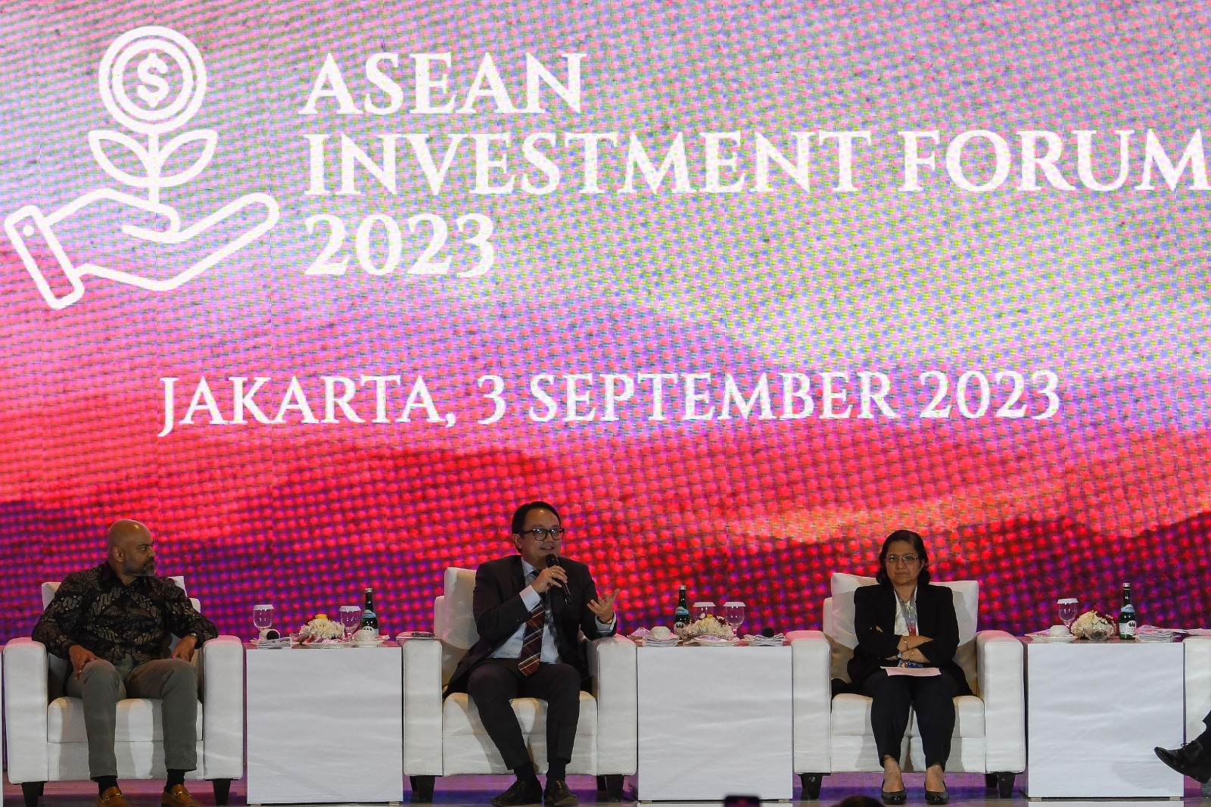

Vice Minister of Trade of the Republic of Indonesia Jerry Sambuaga (middle) with Co-Founder and CEO of FinAccel Akshay Garg (left) and the Director of Trade, Investment, and Innovation of UNESCAP Rupa Chanda (right) speaks in the fifth-panel discussion on the second day of ASEAN Investment Forum at the Sultan Hotel, Senayan, Jakarta, Sunday (03 September 2023). Media Center of the 43rd ASEAN Summit/ Aditya Pradana Putra/pras.

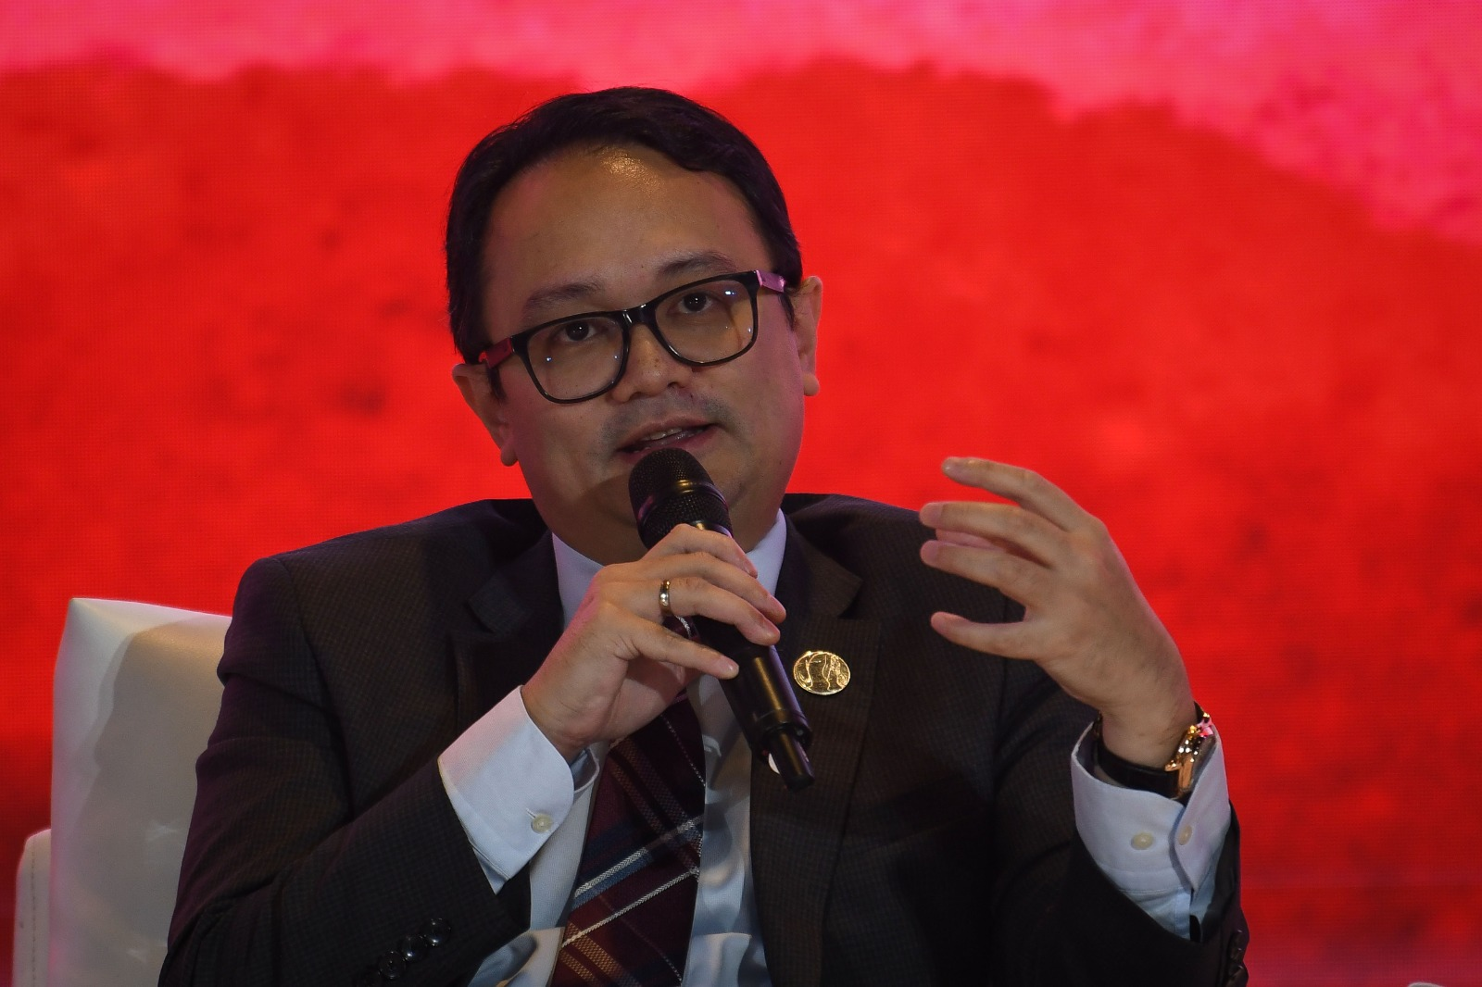
Vice Minister of Trade of the Republic of Indonesia Jerry Sambuaga speaks in the fifth-panel discussion on the second day of the ASEAN Investment Forum at the Sultan Hotel, Senayan, Jakarta, Sunday (03 September 2023). Media Center of the 43rd ASEAN Summit 2023/ Aditya Pradana Putra/pras.

